**ACCIDENT DETECTION SYSTEM**

* Identification of accident prone spot and reporting to the concerned Highway Authority

**Team Name: Fearless Group**

**Team Member**

**Deeban N**

**Indu P**

**Accident Detection System**

**ABSTRACT:**

Our idea is to sending notification to the proper authorities, In case of motorway accidents, must be done efficiently.

Automatic vehicle accident detection is a life-saving application.

The main objective of this project , to create a Real Time Traffic Accident Detection System using Wireless Sensor Network and Radio-Frequency Identification Technologies.

Sensors installed in a vehicle detect the accident's location, and also the vehicle's speed just before the accident and the number of passengers inside the vehicle. Then, those sensors sends an alert signal to a monitoring station. Immediately, the monitoring station tracks the location where the accident has occurred and alerts the authorities concerned to send the rescue team.

**Requirements:**

* GPS sensor : To Track the Location
* Onboard sensor : Sends a message to their

Authorities

* Conventional vehicular sensor system: To detect the accidents
* Resettable crash sensor : Reduce the risk of fire and

Electrical Shock .

**Block Diagram:**

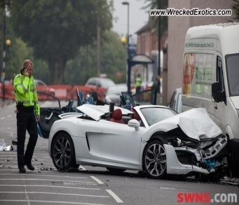

No

No Accident occurs

**Accident Detected**

**Conventional vehicular sensor system**

**Car Accidents YES**

**Small Accidents**

**Resettable Crash Sensor**

** (Even for bigger Accidents)**

**Reduce the risk of Fire & Electric Shock**

**Victim of Accidents Message Passing**

**GPS Sensor**

**Click Manually**

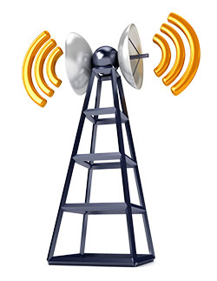

**Rescue Team**

**Concerned Authorities**

**Working :**

* If the Accident Occurs at anytime in any place , at first the Resettable crash sensor reduce the risk of fire and also reduce the risk of electric shock if it is crashed on any lamp post, transformer.
* Then to check it is an accident, Conventional Vehicular Sensor is used that will check the pressure, temperature and so on, then it triggers the GPS sensor and also the ONBOARD sensor to track the location where the accident caused and sends the messages to the Concerned Authorities .
* These all operations will took place simultaneously.

**Solution:**

* Nearly 1,50,000 people die due to road accidents per year. In that 75,000 people die due to late coming of medical help, since the accident information goes late to them.
* If we Implement this idea we can able to reduce those deaths by giving treatment on time .